Webinar and Ask the Expert series 2025:
Theme/title: IP policy management: Building effective and enabling IP policies in academia and public research institutions
Key:
CEST: Central European Summer Time
CET: Central European Time

Comparing regional IP Policy models: The Africa, ASEAN and CATI-CARD examples: Experiences and challenges

Date: Friday, November 28

Time: 14:00 CET

Link: https://wipo-int.zoom.us/j/66846236524?pwd=Pap6baGmkWkbH90qs5WynQfw0f8u1h.1

Africa | Dr. Andrew Mutsiwa, Project Leader, Africa Intellectual Property Center, Harare, Zimbabwe | Andrew has cumulative experience (both theoretical and applied) in the field of intellectual property and, technology law. Currently, Andrew is the Project Leader at the Africa Intellectual Property Center situated in Harare, Zimbabwe.  He has international and regional experience in the field and has consulted for the World Intellectual Property Organization, the African Regional Intellectual Property Organization and the African Intellectual Property Organisation.  He has contributed to Academia and Academic service in local, regional and international universities in different capacities as an Author, An Academic Coordinator and Principal Lecturer, Researcher, Research Ethics Board Member and Technology Transfer Officer. Dr. Mutsiwa is a registered as a Legal practitioner, Notary public and Conveyancer in Zimbabwe and his academic qualifications include a Post-Doctoral Research Fellowship, a Doctorate of Philosophy in Criminology and Intellectual Property, a Master’s Degree in Intellectual Property, and a Bachelor of Laws (Honours) Degree. | 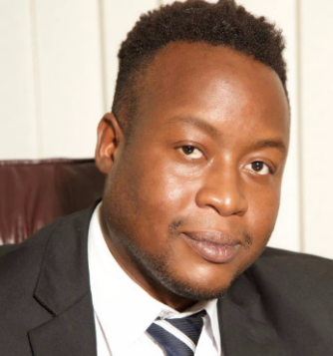
ASEAN | Dr. Richard S. Cahoon, Professor-adjunct, Department of Global Development, Cornell University President, BioProperty Strategy Group, Inc. Expert-advisor, Commercial Law Development Program – US Dept of Commerce | Dr. Richard Cahoon is International IP Professor-adjunct in the Departments of Global Development, and Design Tech at Cornell University. He is also President of BioProperty Strategy Group, Inc, an international intellectual property (IP) management and technology commercialization consulting firm. He was Director of the Technology Transfer Office (TTO) at Cornell University for twenty years and was responsible for the IP and technology transfer policies and functions of the University.  Dr. Cahoon has over forty years’ experience in R&D management, partnerships, commercialization, entrepreneurship, IP strategy, licensing, business development, negotiation, and mediation.  He is an inventor/patentee and advises companies, universities, governments, and non-profit organizations on IP, technology transfer and commercialization policies and practices. He is an Expert Advisor of the International IP Licensing Platform for Vegetable Breeding Companies, headquartered in the Netherlands.  Dr. Cahoon received undergraduate degrees in Political Science and History from the University of Utah, with minors in Biology, Chemistry, and Spanish; an M.S. in Bioprocessing from Montana State, and a PhD, from Cornell in Natural Resources. He has often served as an expert in IP litigations, and has conducted numerous IP/technology valuations and has advised numerous companies in IP management and technology commercialization.  He has been an advisor to the World Bank, the governments of Qatar, Thailand, Philippines, the State of Michigan as well as universities, companies, and NGOs in Turkey, Chile, Japan, Jamaica, Philippines, South Africa, India, Korea, Mexico, Colombia, Brazil, the US, and the European Union. For seven years Dr. Cahoon led a multi-year project in eight countries, for the World Intellectual Property Organization (WIPO) to establish innovation systems in developing countries through IP/technology transfer from public-sector research institutions. Dr. Cahoon and Cornell have just launched an on-line Cornell University certificate course on Invention & IP Management. | 
ASEAN | Dr. Orakanoke Phanraksa, PhD, Intellectual Property Policy Manager, Technology Licensing Office, Technology Management Center at the National Science and Technology Development Agency, Pathumthani, Thailand | Dr. Phanraksa is a policy specialist in the field of intellectual property laws at the National Science and Technology Development Agency (NSTDA), Thailand. Currently, she is serving the Technology Licensing Office as senior consultant. She has been playing a key role to form a policy framework to promote and strengthen technology licensing offices  and IP professionals in the academic and research institutions in Thailand. In 2019, she was the first to be awarded the Global IP Champion Award from the Global Innovation Policy Center, US Chamber of Commerce. This award was given to five individuals in the field of intellectual property who are leading efforts to bring about positive change in their communities and around the world. In 2023, she was selected as one of the five regional IP Policy experts by the WIPO to develop the IP Policy Model for Universities and Research institutions in ASEAN.  Dr. Phanraksa is passionate in promoting early to mid-career researchers. She was one of the past Co-Chairs of the Global Young Academy (2015/2016). She is co-founder and Co-Chair of the ASEAN Young Scientists Network where she enjoys sharing her IP experiences to the community of young scientists in ASEAN. In 2022, she was selected as an International Science Council Fellow. She is experienced in policy development by  serving the Minister of Higher Education, Science, Research, and Innovation (MHESI) Thailand from 2020-2022. In 2023, she was appointed as an adjunct professor at Sunway University, Malaysia. | 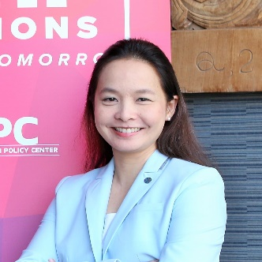
CATI-CARD | Mr. Juan Carlos Suárez Delgadillo, Director of Intellectual Property and Technology Transfer, Bosque University, Colombia | Mr. Juan Carlos Suárez Delgadillo is an Intellectual Property Management and Technology Transfer expert specializing in Latin America and the Caribbean's university sector. He currently serves as Director of Intellectual Property and Technology Transfer at Bosque University (Colombia) and advises on the IP University Policy Model for the CATI CARD TISc Network. He holds a law degree (Externado University/Colombia) and an LLM in Intellectual Property from Ankara University/WIPO (Turkiyi). His expertise is enhanced by advanced training in IP Management and Technology Transfer from institutions in the USA, France, Israel, and Singapore. He is a WIPO Consultant and frequent international speaker on IP Management in academia. | 